**Crop Prediction ML Project**

This project uses ML to predict the best suitable crop according to the soil condition.

Input:

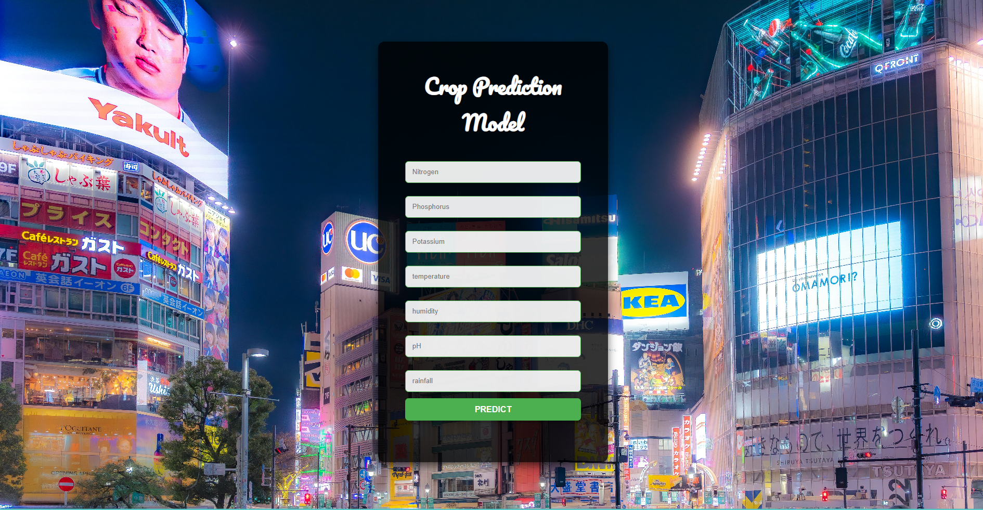

Based on the input project predicts the best suitable crop for the soil condition:



Predicted Crop:



Thanks & Best Regards,

Mayank Tyagi